The Day I Found Sheena

We were on our way to get our third dog. It was a hot May afternoon and the car was boiling. I hoped the dog would be ok in the heat of the car.

We had had two dogs before now: First Lucy, then Jess. Neither had turned out successful. I was hoping third time lucky! My Dad, brother and I arrived at the dog shelter.

A woman came out to greet us and left for a moment and then returned with a dog on a lead. The woman said the dog's name was Sheena! Sheena was very similar to a rough collie except for some differences in appearance. Her head was more like a border collie's but she was a lot taller than one. She also had a black and white coat which is quite unusual for a rough collie.
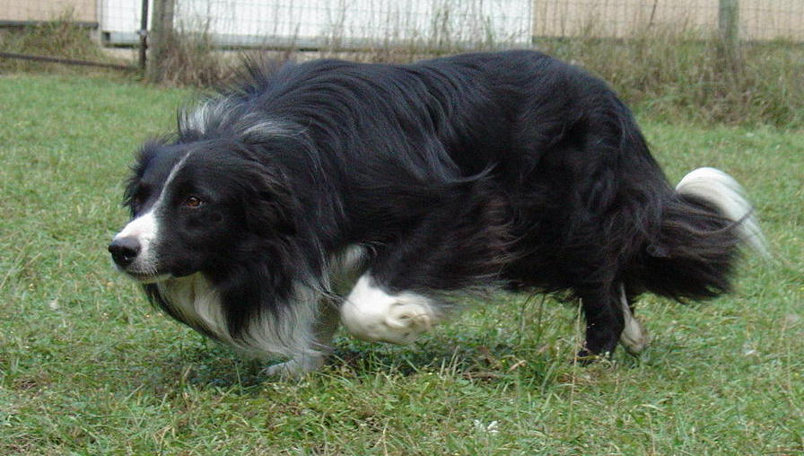

Speaking of her coat, it was very matted but we could brush it out and other than that she was a stunning dog! We were told she was a very good natured dog and great with kids. But we were also told that she had been abused as a puppy and was slightly nervous.
We put that in mind and decided we wanted to take her home with us.

I was delighted we had a dog again! Everything went upwards from then on. Sheena was extremely intelligent and was really obedient. We got all the matting out of her coat and had brought her fitness up a huge amount.

I was so, so happy we had her and she just loved the attention from all the family not including my little sister practically hanging off her and claiming she was just 'petting' her!

After a while we decided to let her off the lead on a walk. That's when things went downwards. On the walk, we came across another walker and her dog. Sheena was off the lead and saw the other dog. She ran forward and I called her back but she just ran on. When she got to the dog she attacked it savagely and the other dog was trying to run away. I was shocked at Sheena's vicious behaviour and I grabbed her as quick as I could.

I decided then I wouldn't let her off the lead again.

After that we couldn't let her outside without a really long lead. We still wanted her to have some freedom. Then she got very protective of us.

My aunty had been down and we were saying goodbye to her. My Dad went to give her a hug and when he did, Sheena ran forward and nipped the back of my aunty's leg! Then in February, my brother brought her out for a walk and he told us that on the way home, he had bumped into our neighbour on the walk. She did not have a dog.

She went to rub Sheena but Sheena ducked under her arm and bit her! When Jack told us that when he got back, we knew that was the last straw.

Within a week, she had gone back to the shelter for good. I was so sad she was gone. I couldn't believe we had lost a third dog.
Since then, I've been wondering... Is there such thing as fourth time lucky?

Éabha Ní Annagáin
12.11.09

