1. Name the river that flows through Prague in the Czech Republic
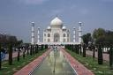
2. Where would you find the Taj Mahal?
3. If you were to celebrate the festival of Divali, what religion would you belong to?
4. In what part of the body would you find the patella?
5. What is a tabor used for?

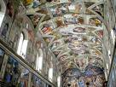
6. In what Italian city would you find the Sistine Chapel?
7. Ainmnigh trí leabhar scríofa le Dick King Smith
8. Find the German words for: a dog, twelve, mother, table, music

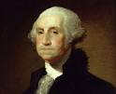
9. Who was the first president of the US?
10. Cathain ar rugadh é? (When was he born?)

11. What kind of animal is an ocelot?
12. Name three types of cloud

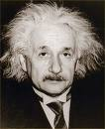
13. Cár rugadh Albert Einstein? (Where was Albert Einstein born?)
14. What is the name of the deepest lake in the world?
15. Kangaroos belong to what group of animals?

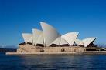
16. What is the name of this building?

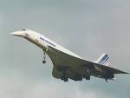
17. Ainmnigh an t-eitleán seo. (What is the name of this aeroplane?)
18. What instrument is used to measure air pressure?
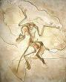
19. What famous dinosaur fossil showed evidence of feathers?
20. Cad ab ainm do Chúchulainn nuair a bhí sé óg?

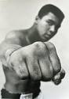
21. What did Cassius Clay change his name to?
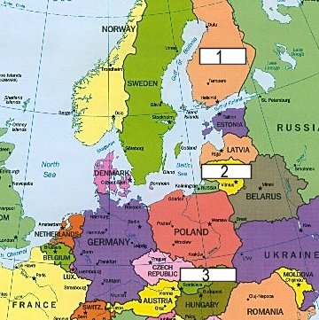
22. Name these three countries
23.What does the word contravene mean?
24. What is glass made from?
25. What is the principal religion in Saudi Arabia?

